Housing Prices

Anna Olena Zhab'yak, Michele Maione

**Summary** – This paper implement the ridge regression and the --- to the dataset of housing prices in order to predict the median value of the house.

# Introduction and description of the problem

The most common problem with large dataset is the multicollinearity of the features which tend to overfit when it comes to implement a certain algorithms in order to predict the value. This is one of this cases where the value of a house is given by a relationship of more features that sometimes can be treated as one and not in group.

The ridge regression is a machine learning method that helps to overcome the problem of multicollinearity by introducing panalities on the …. And the …

The importance of having a good algorithm that can precict the median house value given the features.

The importance of the bias.variance trade off and the analysis of the risk minimization given different algorithms will be provided

This paper is trying to answer to the question, wthat is the best model to predict the median house price given the house characteristics aka features

# Most important related works

The hypothesis of this study is that Kriging will create an accurate spatial interpolation of house prices in Austin based on the spatial autocorrelationproperties of real estate.[[1]](#footnote-1)

Method of predicting house values is to use data on the characteristics of the area’s housing stock to estimate a hedonic regression using OLS as the statistical technique. The coefficients are then used to produce the predicted house prices.

For the spatial correlation incorporation into the prediction kriging is used as well. [[2]](#footnote-2)

# Notation and relevant definitions

Linear regression

And what's the equation of a line?

Well, it's just intercept plus slope times our variable of interest so

that we're gonna say that's wo + w1x.

And what this regression model then specifies is that each one of our

observations yi is simply that function evaluated at xi.

So that's w0 plus w1xI plus the error term which we called epsilon i.

So this is our regression model, and to be clear, this error, epsilon i,

is the distance from our specific observation back down to the line. [[3]](#footnote-3)

when there are a lot of features to regress, we face an hyperplace that gives the relation between all the inpunts and the output of interest.   
The interpretation of the coefficients near every single feature is how does the median value price change if one feature is changing, having everything else constant

Hyperplanes of the

form{x∈Rd:w>x= 0}

{x∈Rd:w>x=c}, with c =| 0, is equivalent to thehomogeneous hyperplane{x∈Rd+1:v>x= 0}withv= (w1,...,wd,−c) in the following sense:w>x−c=v>x′for allx∈Rdandx′= (x1,...,xd,1)∈Rd+1. For this reason, without any loss ofgenerality we only deal with algorithms that learn linear predictors corresponding to homogeneoushyperplanes. This amounts to saying that we automatically add an extra feature with value 1 toall of our data points.

If incease features we talk about hyperplanes

Multiple regression model

Use **matrix notation** for derive the linear predictor

Each observation can be rewtitten as an inner product between two vectors, w and h(x).

yi = ∑wjhj(xi) + ei



SinceF(w) =‖Sw−y‖2is a convex function, the minimizer satisfies the condition∇F(w) =0.Using matrix calculus, we have that∇‖Sw−y‖2= 2S>(Sw−y). Hence,∇‖Sw−y‖2=0forw=(S>S)−1S>yprovidedS>Sis nonsingular (i.e., invertible) —which is equivalent tox1,...,xmspanningRd. When this happens, we have that the ERM with respect to the square loss iŝw=(S>S)−1S>y.

His is a so called closed- form solution

If we multiply the two matrices i have n columnd and d rowd and i will end up with a matrix that is DxD matrix, take the inverse of the matrix, in most cases if the number of observations we have is larger then the number of features , the matrx is invertible. .

Number of linearly independent observations greater than the number of features

The other approach is the gradient descent

We set the first step , initialize w, to 0 or random stuff.

We said while the gradient of our residual sum of squares,

the magnitude of that gradient is sufficiently large.

Larger than some tolerance epsilon then we were going to keep going.

## Empirical Risk Minimization

It’s a principle that defines a family of algorithms of learning and it’s used to give theoretical limits to their performance. The risk is how well an algorithm will work in practice, because we don’t know the distribution of the data that it will work on, but we can measure the performance on a training test, that is the empirical risk.

$$\hat{f}∈{argmin}_{f∈F} \hat{l}(f)$$

## GRADIENT DESCEND

In order to find the value that minimize the error the technique used is the gradient descend, that means .

In order to implement this technique we need a convex set; in out case it is like that

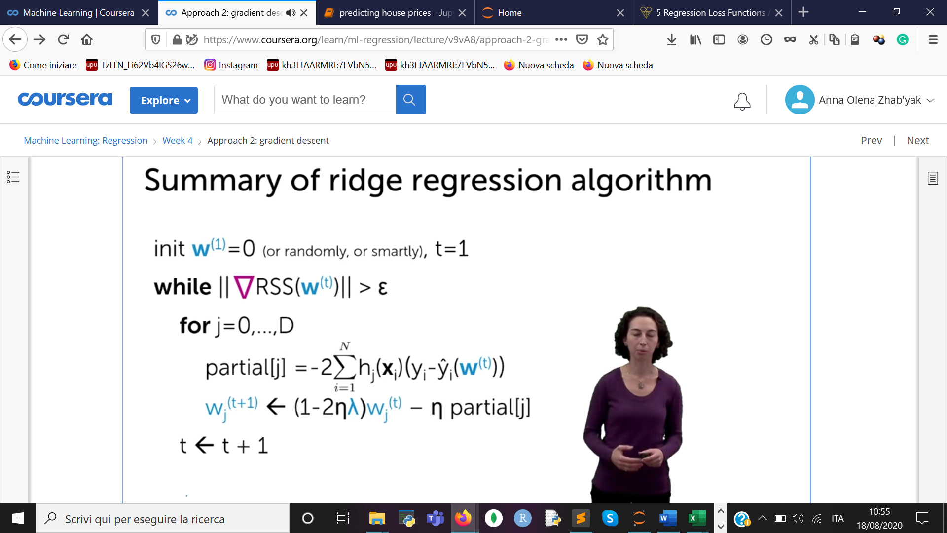

CLOSED FORM SOLUTION

For a specific value of a

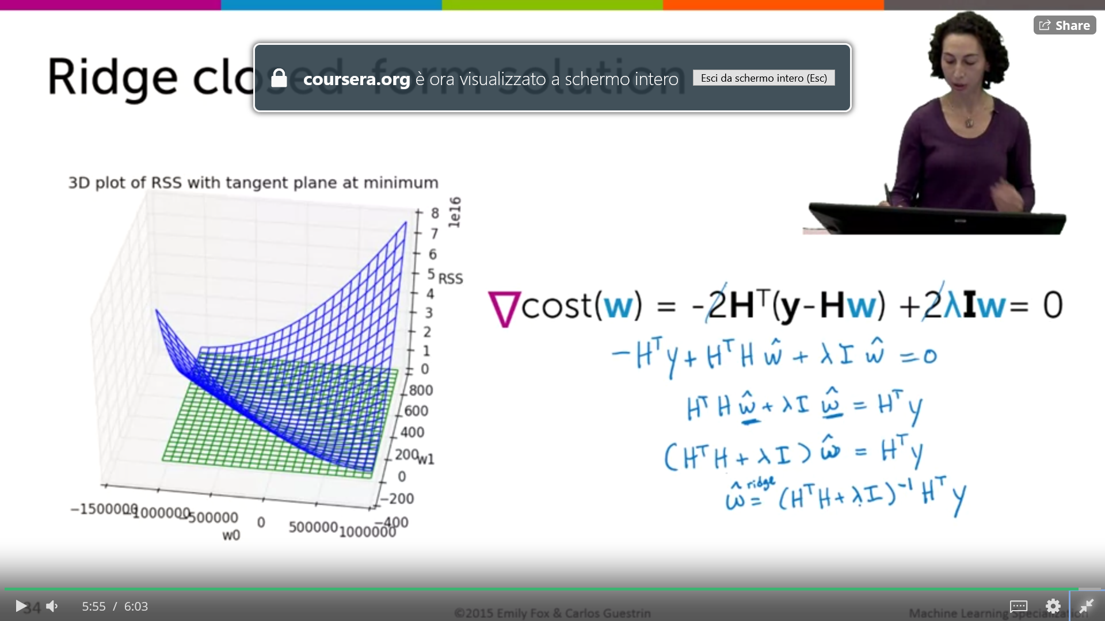

If a is 0 = w rudge is = what least squares

Il a infinity = w ridge is zero

## Loss function

Loss due to an inaccurate median house value

Loss function is when the prediction mde by the algorithms used do not correspond to the true y

Ia a function of the predicted function of y, using the estimated w hat, and the true value

Common ways of defining loss function

And another common choice is something called squared error, where, instead of

just looking at the absolute value, you look at the square of that difference.

And so that means that you have a very high cost if that difference is large,

relative to just absolute error.

<https://heartbeat.fritz.ai/5-regression-loss-functions-all-machine-learners-should-know-4fb140e9d4b0>

l2 vs l1

L1 loss is more robust to outliers, but its derivatives are not continuous, making it inefficient to find the solution. L2 loss is sensitive to outliers, but gives a more stable and closed form solution (by setting its derivative to 0.)

**generalisation error**

then we have our loss function, assessing the cost of predicting f,

this f sub w hat at our square foot x when the true value was y.

And then what we're gonna do is we're gonna average over all possible xy's.

But weighted by how likely they are according to those distributions over

square feet and value given square feet.

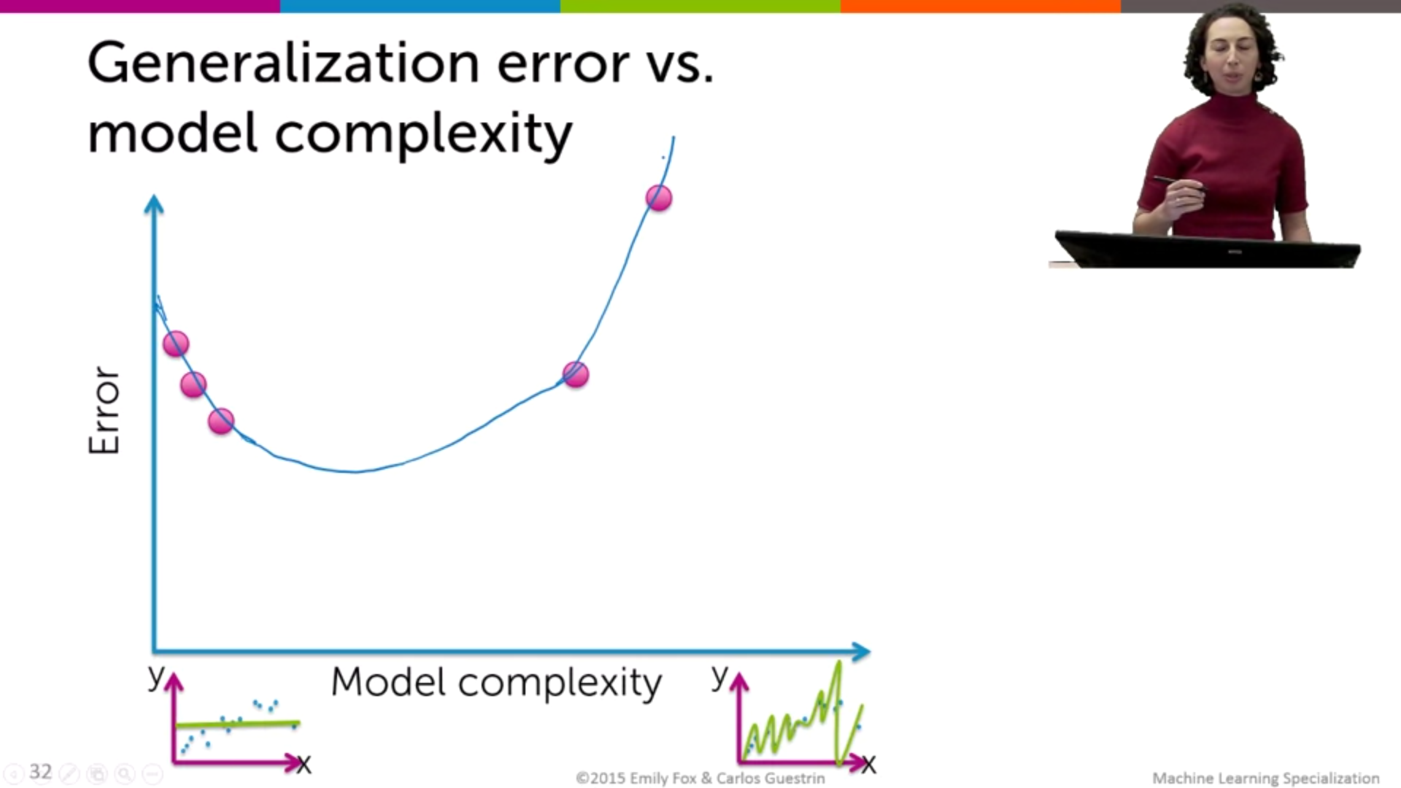

This is an ideal picture but we cannot compute the generalisation error.

So we have approximate the generalization error using the test error.

**Training error vs test error**

**Training**

(f) =1mm∑t=1`(yt, f(xt))

Sum of the loss in the training observations, the estimated parameters didi in the training set.

Difference between the actual and predicted house median value

Ones the optimal predictor w hat is set within a range of possible predictors , using the optimization techniques, we can see how is the error behaviour in train and test set, plotting the complexity of the model vs error

Adding more comlexity to the model the training errori s minimized so it converges to zero as we increase it it means that more complexity gives us a better fitting of the algorithm wrt to the given training data.

Error vs model complexity plotted on the best w hat.

Model complexity is the different models , linear, polinomial, more polinomial etc…

So when we think about holding out our test data, fitting a 13th order

polynomial just on the training data, we're gonna get some wiggly, crazy fit.

And then when we look at those test observations, those houses that we

held out, we're probably gonna have very poor predictions of those actual values.

So what we're gonna expect is that at some point,

our test error is likely to increase.

So the curves for test error tend to look something like the following

where maybe the error is going down for some period of time but after a point

**test error**

is the avarage loss on houses in the test set

Give a loss function`, the test set is used to compute thetest errorof predictorsf,1nn∑t=1`(y′t, f(x′t)).

The function is given by the training data and the set used is the fresh dataset, test data.

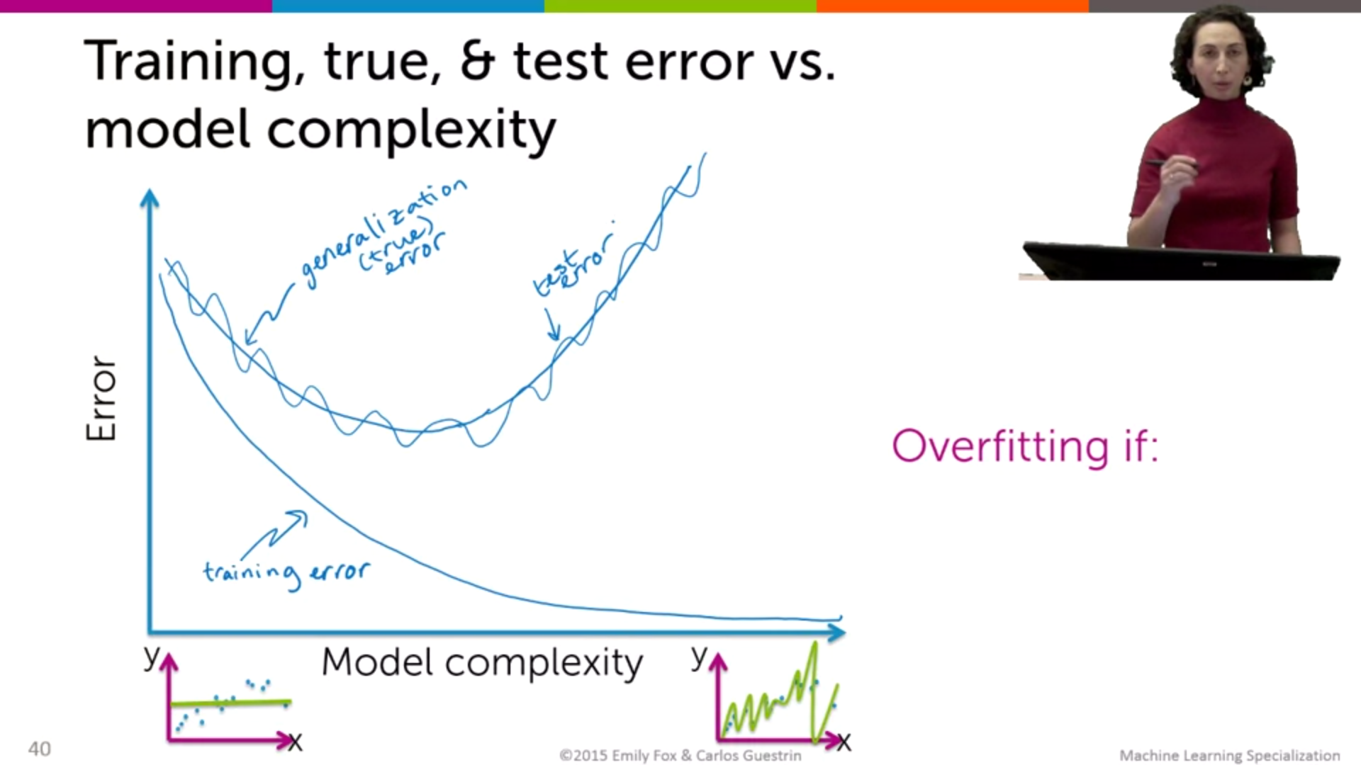

Overfitting vs underfitting

If we have some model with parameeters w hat, and with some complexity , is overfit if there exist a model with estimated parameters w’ , so other parameters, such that two conditions hold

1. Training error of w hat is less than the training error of w’
2. True error of w hat is greather than the true value of w’

Good in training set but do not generalize well

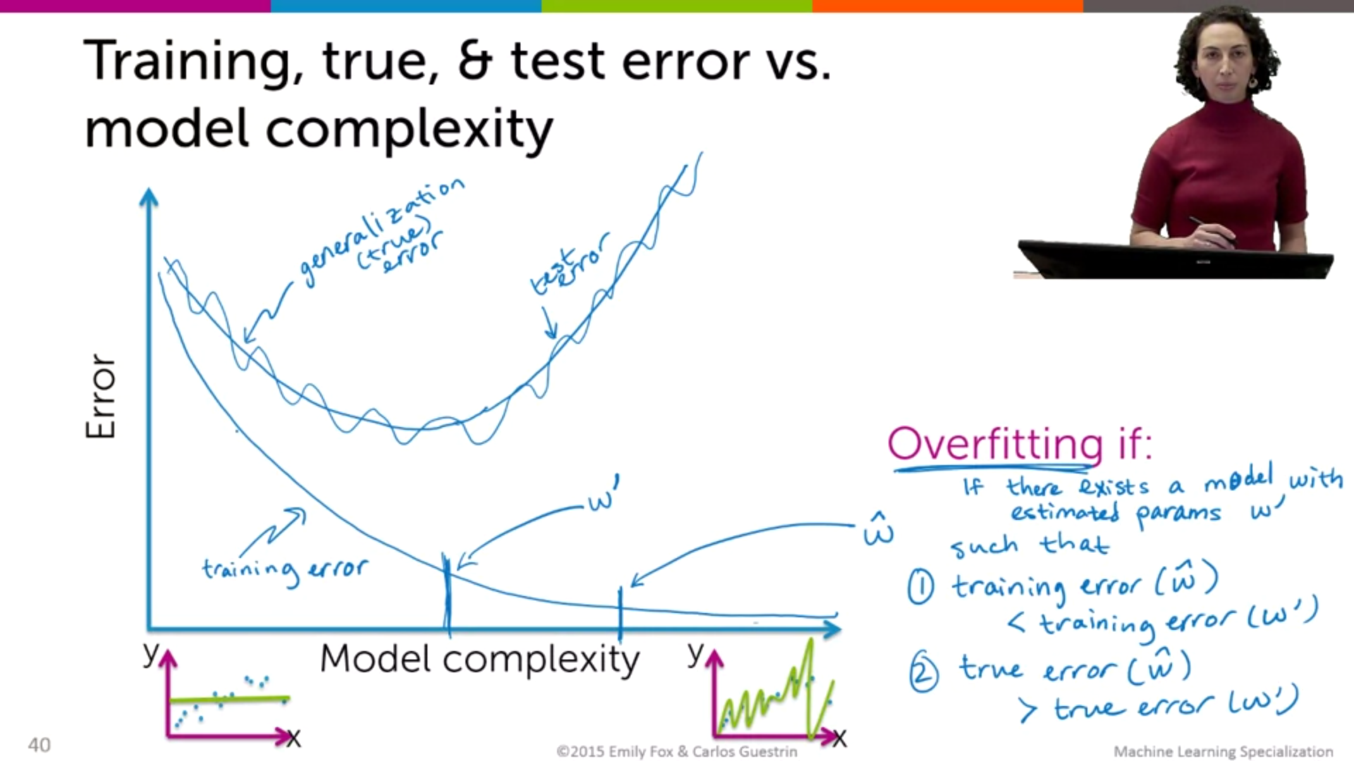

Bias variance trade off

Irreducible error

Noise of data, is the variance noise

Reducible

Bias : how well the model can fit the true relationship btw x, y.

So what we are saying is, over all possible data sets of size N that we might

have been presented with of house sales, what do we expect our fit to look like?

So for one data set of size N we get this fit.

Bias is the difference between it’s true function and the avarage fit

Is the model flexible enough to be able to capture the true relationship?

Low complexity --- high bias ---low variance

So it leads to error in the prediction

How much the prediction is sensitive to the dataset we have.

Hight complexity models

Hight variance --- low bias

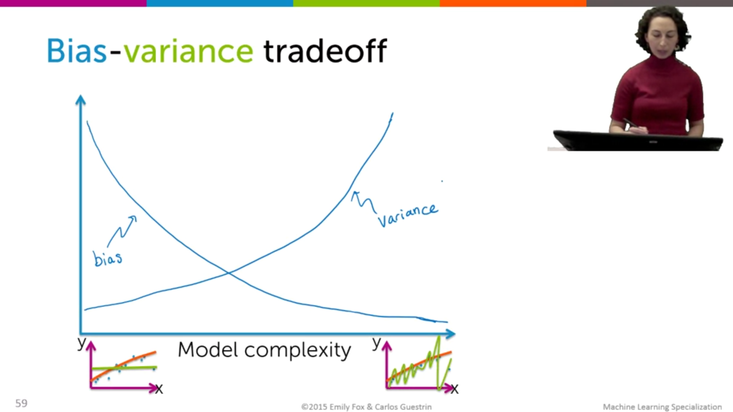

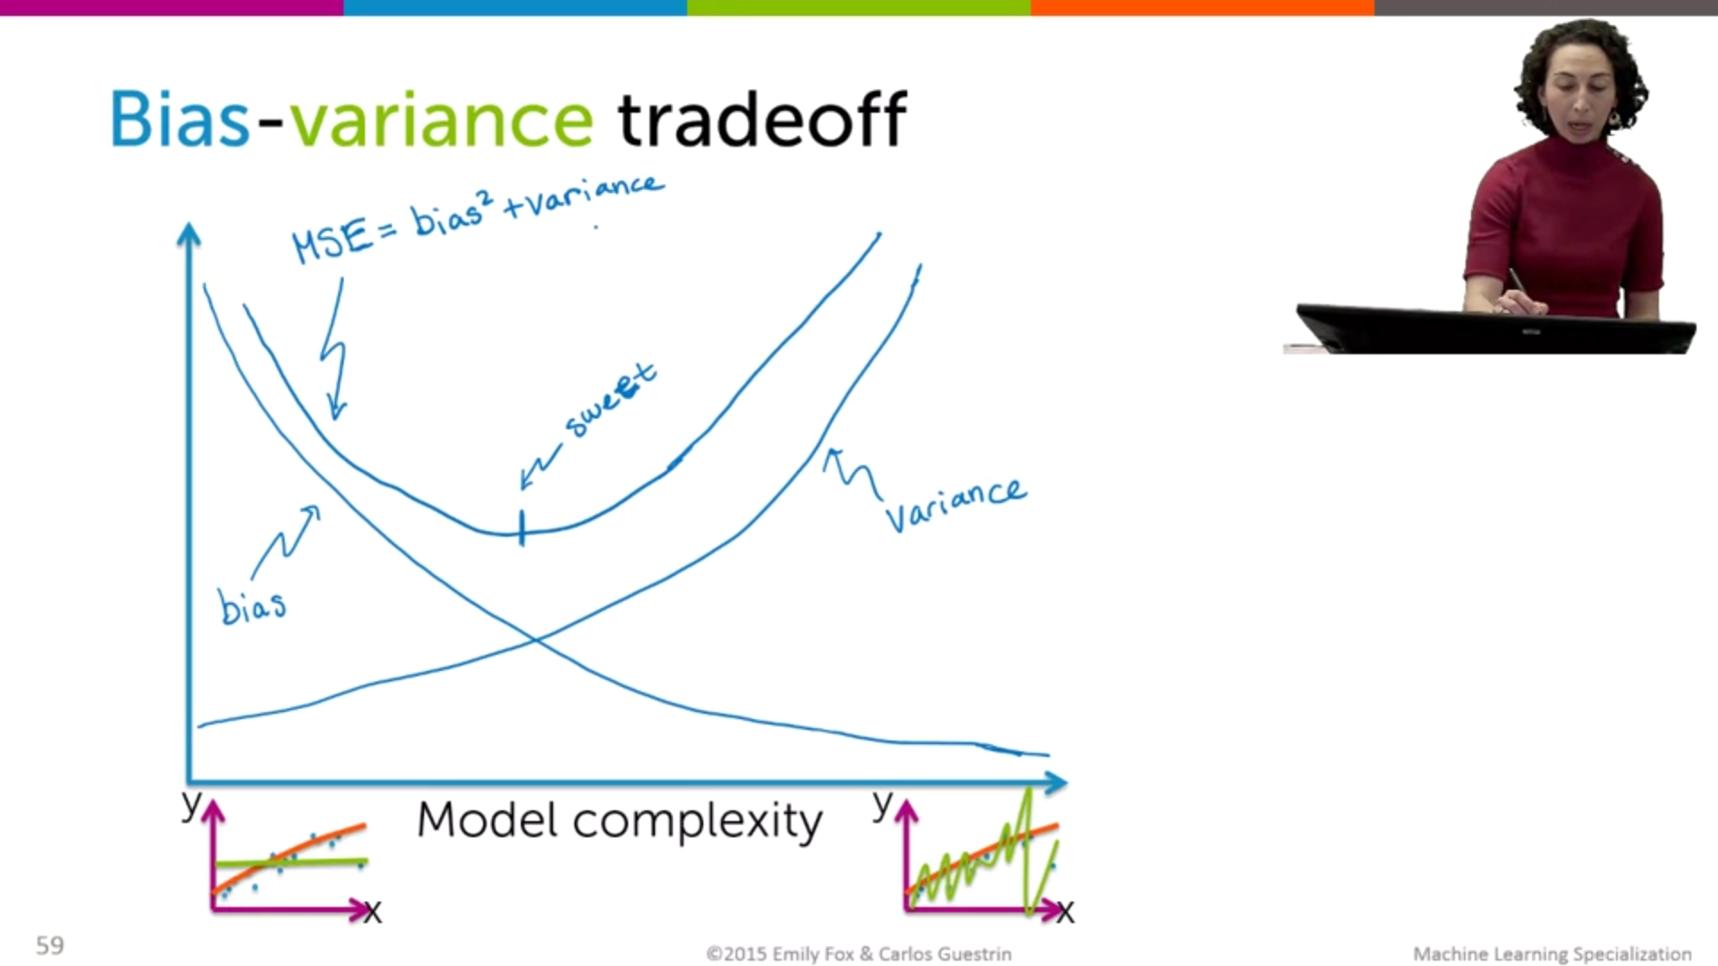

We want the sweet spot

But we cannot compute bias the variance, because they are defined as the true functions, but all possible datasets we do not have them

So we can just optimize them

Error vs amount of data for a fixed complexity

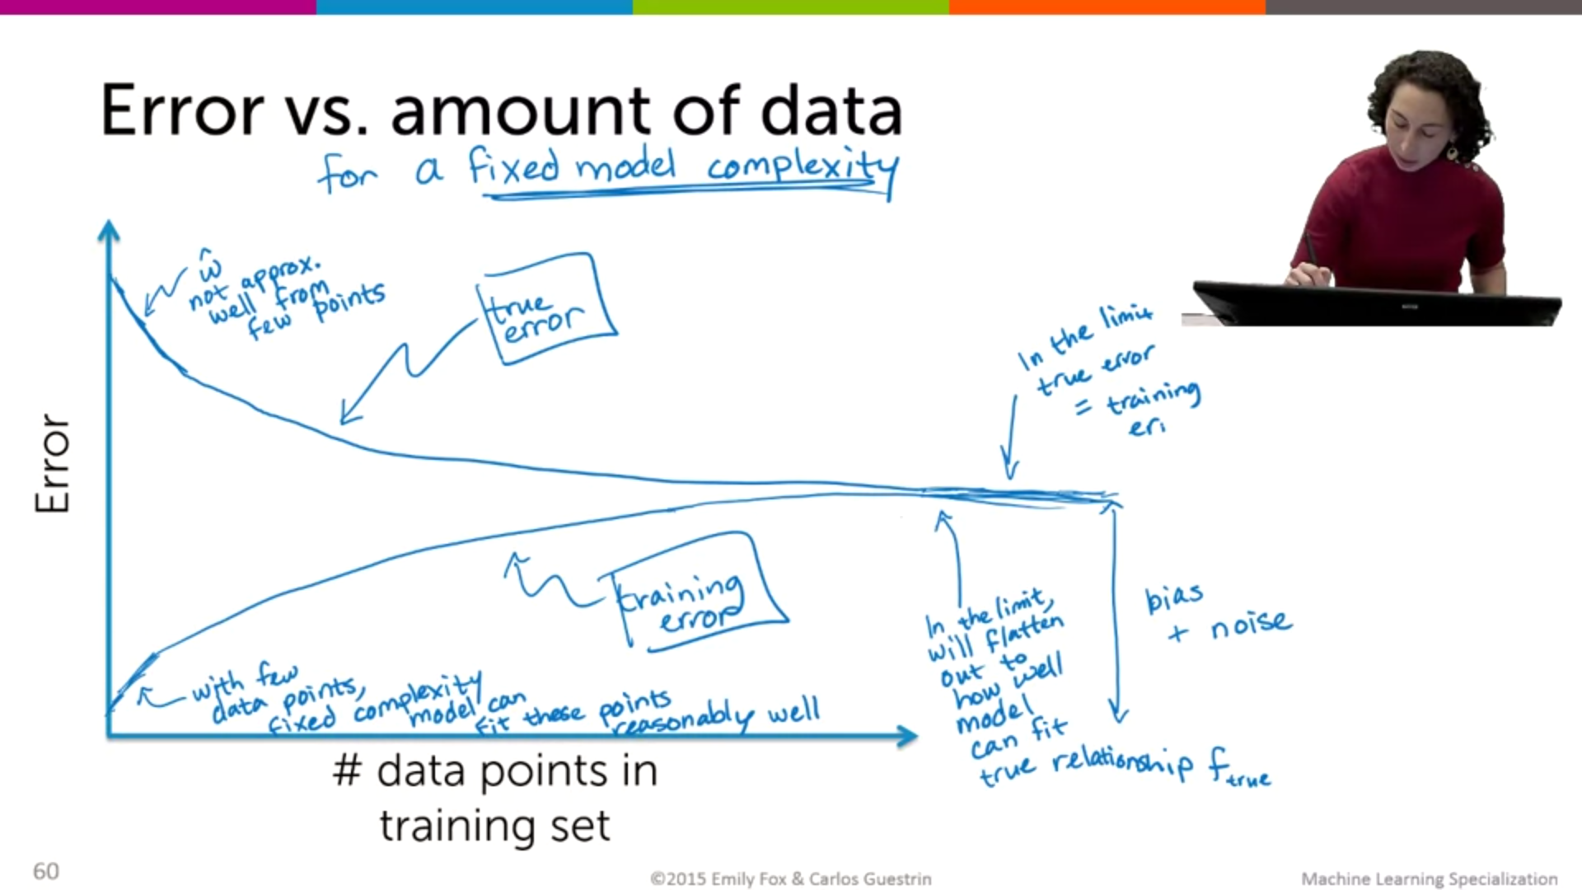

## Ridge Regression

Why ridge?

high complexity models to become overfit to the data.

And we also discussed this idea of a bias-varience tradeoff.

Where high complexity models could have very low bias, but high variance.

Whereas low complexity models have high bias, but low variance.

And we said that we wanted to trade off between bias and

variance to get to that sweet spot of having good predictive performance.

And in this module, what we're gonna do is talk about a way to automatically balance

between bias and variance using something called ridge regression.

Again, this is an instance of a high variance model.

But we refer to this model or this fit as being overfit.

Because it is very, very well tuned to our training observations, but

it doesn't generalize well to other observations we might see.

So, previously we had discussed a very formal notion of what it means for

a model to be overfit.

In terms of the training error being less than the training error of another model,

whose true error is actually smaller than the true error of the model with

smaller training error.

Large coefficients: overestimation (?)

So what ridge regression is gonna do is it's going to quantify

overfitting through this measure of the magnitude of the coefficients.

More in generale where D is a large nimber, so we have lots of features , the regression model has a lot of fleibility to explain the data and there is the risk of overfitting

Overfitting for nimber of N

Model can rapidly overfit the data, if n small

Is n is large, not that quickly overfitting. And it is harder to overfit. But it is difficult.

Specially if the features are a lot, so it is likely to overfit. In our case it is likely to overfit.

How well function fix the data

And magnitude of estimated coefficients.

Total cost = measure of fit (small number is a good fit) + magnitude of coefficient (if small is ok)

If set coefficients to zero we will not overfit but we will not fit the data well , so i twill be a very hight bias solution.

On the other hand if i just focused on optimizing the measure of fit , we will have more complex models and so more likely to overfit.

* Measure of fit data ( is the rss, we can call the loss function )

Small rss indicate the model fitting the training data well

* Measure of magnitude of coefficients

Sum of absoute values? It is the norm of the vector of all w.

* But we can sum the squared coefficients

Is the norm ||w||22 is the l2 norm squared

Totoal cost = rss(w) + ||w||22

We are looking over all w that minimize the total cost , we want to control how much we are weighting the complexity of model as measured by the magnitude of coefficients with some magnitude

We now introduce a regularizer parameter, α > 0, in the ERM functional: our objective becomes

If a is zero = we have the classical least squares solution

If a is infinity : any solution where w hat is note qual zero the tolat coast is infinity

If w hat equal zero then total coast i s equal to the rss of a zero vector.

A is between 0 and infinity, the magnitude ||w||22 is less then or equal to the || w||22 least square coefficients , and greather then of equal to zero.

What a we want?

L2 regularization, regularizing the solution to the old objective od least squares using the l2 norm

RIDGE REGRESSION AND BIAS VARIANCE TRADE OFF

Large a ---------------small a

Hight bias low bias

Low varance high variance

Ex w hat = 0 rss

A controls model complexity and the bias variance trade off

If a is small, coeffcients are high

See for different values for a

How to choose the a automatically

Plot cross validation of different values of a, and select them , plot

Oefficient path of the ridge regression

Lambda values vs coefficients

CROSS VALIDATION

And the answer, and this is the key insight, is use all of the data subsets.

Because if you're doing that,

then you can think about averaging your performance across these validation sets.

And avoid any sensitivity you might have to one specific choice of validation set

that might give some strange numbers because it just has a few observations.

It doesn't give a good assessment of comparison between different model

complexities.

[MUSIC]

k-fold

How are we gonna use all of our data as our validation set?

We're gonna use something called K-fold cross validation.

Where the first step, it's just a preprocessing step.

Where we're gonna take our data, and divide it into K different blocks.

And, we have N total observations, so, every block of data is gonna have N over

K observations, and these observations are randomly assigned to each block.

Okay, then for each one of these K different blocks,

we're gonna cycle through treating each block as the validation set.

And using all the remaining observations to fit the model for

every value of lambda.

So in particular, we're gonna start by saying for a specific value of lambda and

we're gonna do a procedure for each of the K blocks and

at the end we're gonna cycle through all values of lambda.

So for right now, assume that we're looking at a specific lambda value out of

a set of possible values we might look at.

And now we're gonna cycle through each one of our blocks where

at the first iteration we're gonna fit our model using all the remaining data.

That's gonna produce something that I'm calling w hat lambda, so

indexed by this lambda that we're looking at.

So we're considering the first block as our validation set.

Then we're gonna take that fitted model and

we're gonna assess it's performance on this validation site.

That's gonna result in some error which I'm calling error sub one.

Meaning the error on the first block of data for this value of lambda.

Okay, so I'm gonna keep track, of the error for the value of lambda for

each block, and then I'm gonna do this for every value of lambda.

Okay, so I'm gonna move on to the next block,

treat that as my validation set, fit the model on all the remaining data,

compute the error of that fitted model on that second block of data.

Do this on a third block, fit data on all the remaining data, assess

the performance on the third block, and cycle through each of my blocks like this.

And at the end, I've tabulated my error

across each of these K different blocks for this value of lambda.

So we're considering the first block as our validation set.

Then we're gonna take that fitted model and

we're gonna assess it's performance on this validation site.

That's gonna result in some error which I'm calling error sub one.

Meaning the error on the first block of data for this value of lambda.

Okay, so I'm gonna keep track, of the error for the value of lambda for

each block, and then I'm gonna do this for every value of lambda.

Okay, so I'm gonna move on to the next block,

treat that as my validation set, fit the model on all the remaining data,

compute the error of that fitted model on that second block of data.

Do this on a third block, fit data on all the remaining data, assess

the performance on the third block, and cycle through each of my blocks like this.

And at the end, I've tabulated my error

across each of these K different blocks for this value of lambda.

And what I'm gonna do is I'm gonna compute what's called the cross validation error

of lambda,

which is simply an average of the air that I had on each of the K different blocks.

So now I explicitly see how my measure of air, my summary of air for

the specific value lambda uses all of the data.

it's an average across the validation sets in each of the different blocks.

Then, I'm gonna repeat this procedure for every value that I'm considering of lambda

and I'm gonna choose the lambda that minimizes this cross validation error.

So I had to divide my data into K different blocks in order to run

this K full cross validation algorithm.

So a natural question is what value of K should I use?

Well you can show that the best approximation to the generalization error

of the model is given when you take K to be equal to N.

And what that means is that every block has just one observation.

So this is called leave-one-out cross validation.

**How to handle intercepts**





Or center the data



# Proof of a technical result

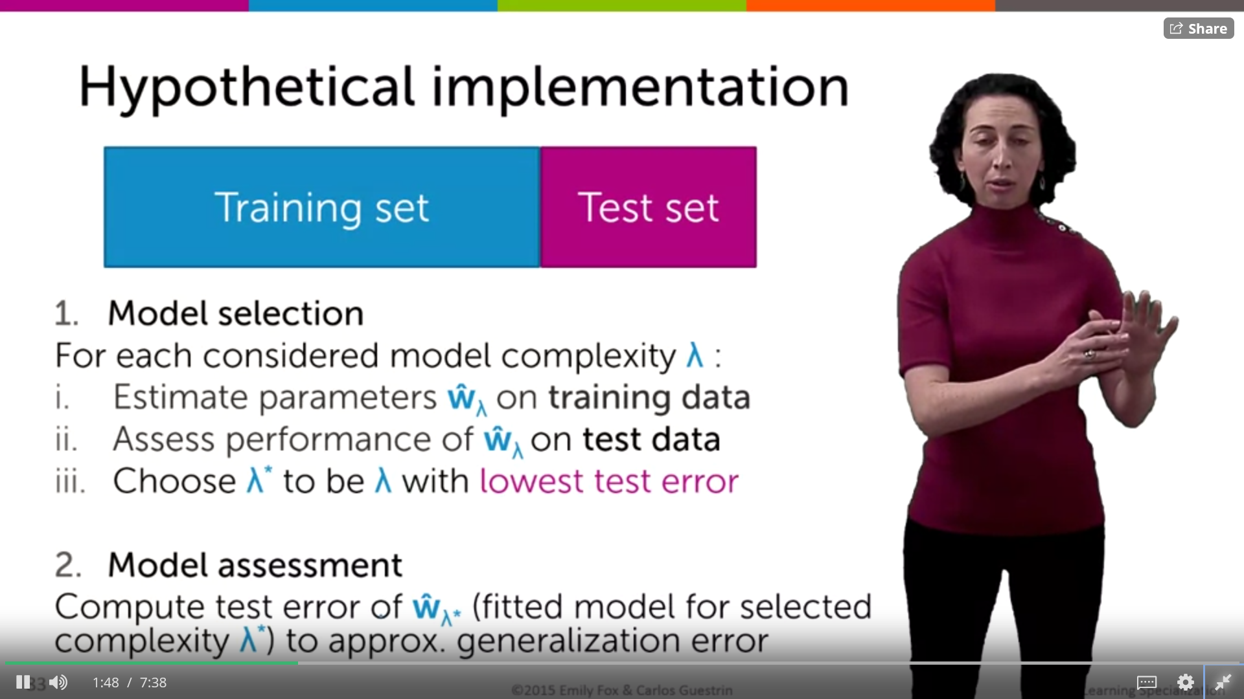

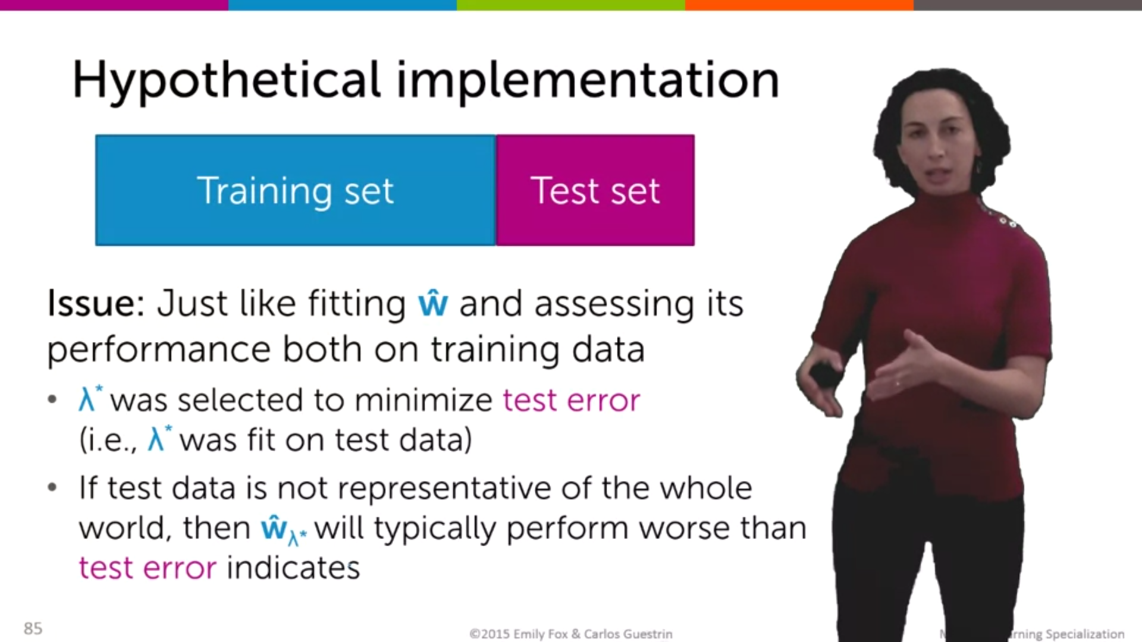

Validation set

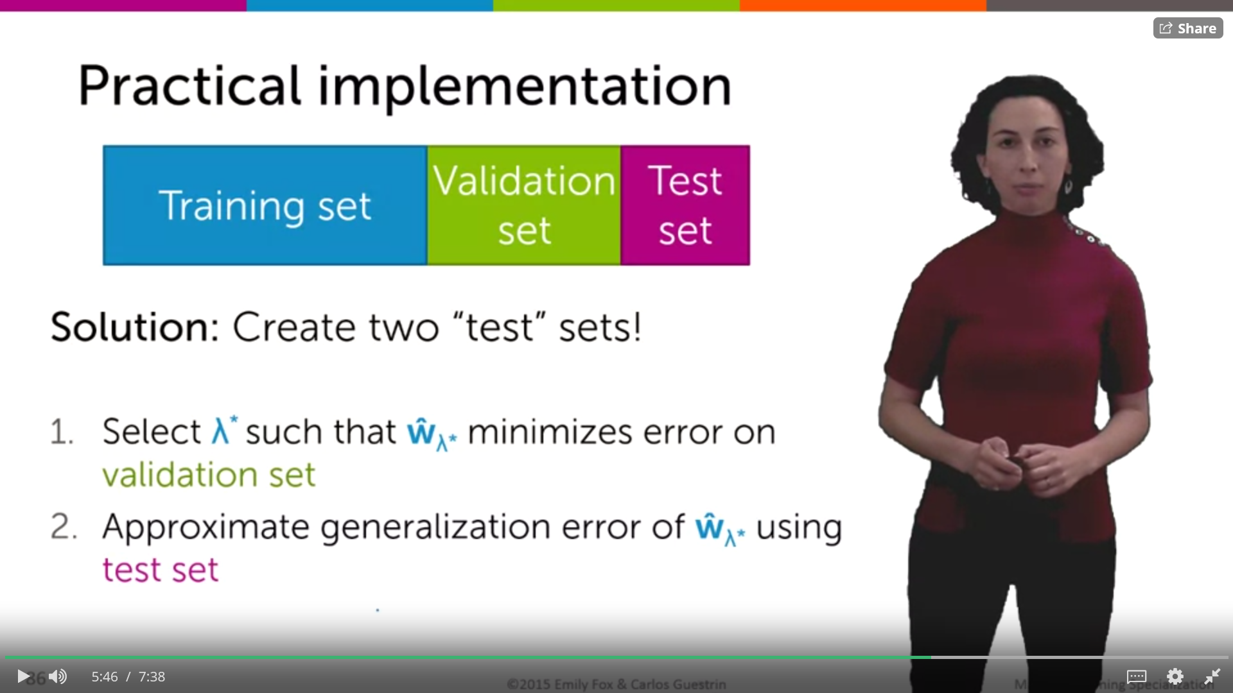

*So, what's our solution?*

*Well, we can just create two test data sets.*

*They won't both be called test sets, we're gonna call one of them a validation set.*

*So, we're gonna take our entire data set, just to be clear.*

*And now, we're gonna split it into three data sets.*

*One will be our training data set, one will be what we call our validation set,*

*and the other will be our test set.*

*And then what we're gonna do is, we're going to fit our model parameters always*

*on our training data, for every given model complexity that we're considering.*

*But then we're gonna select our model complexity as the model that*

*performs best on the validation set has the lowest validation error.*

*And then we're gonna assess the performance of that*

*selected model on the test set.*

*And we're gonna say that that test error is now an approximation of our*

*generalization error.*

*Because that test set was never used in either fitting our parameters, w hat,*

*or selecting our model complexity lambda, that other tuning parameter.*

*So, that data was completely held out, never touched, and*

*it now forms a fair estimate of our generalization error.*

*So in summary, we're gonna fit our model parameters for*

*any given complexity on our training set.*

*Then we're gonna, for every fitted model and for every model complexity,*

*we're gonna assess the performance and tabulate this on our validation set.*

*And we're gonna use that to select the optimal set of tuning parameters*

*lambda star.*

*And then for that resulting model, that w hat sub lambda star,*

*we're gonna assess a notion of the generalization error using our test set.*



*Well the probelm is if we have not enough data to do this split into three tests*

4.1 Data cleaning, preparation and tranformation

Model selection

Model assessment

4.1 algorithms used

The model used is the ridge regression

Ridge regression

The database contains different features for all the records. The median house value i salso contained.

In order to perform the regression, the dataset is splittet into training and test set and the colum of the median house value is cancelled out, so we can compare afterwards the results.

To see how good is our model we perform the mean squared error

calculating error will be, to calculate the difference in the predicted and actual values. However, if we simply add them, they might cancel out, so we square these errors before adding. We also divide them by the number of data points to calculate a mean error since it should not be dependent on number of data points.[[4]](#footnote-4)

Cross validation

# Some critical considerations

# Copyright

We declare that this material, which We now submit for assessment, is entirely our own work and has not been taken from the work of others, save and to the extent that such work has been cited and acknowledged within the text of our work. We understand that plagiarism, collusion, and copying are grave and serious offences in the university and accept the penalties that would be imposed should I engage in plagiarism, collusion or copying. This assignment, or any part of it, has not been previously submitted by us or any other person for assessment on this or any other course of study.

# Bibliographical references

* Ramsay J. & Huber M. (1987) - The Techniques of Modern Structural Geology. Volume 2, Folds and Fractures. Academic Press, London, 391 pp.
* Ramsay J. & Huber M. (1987) - The Techniques of Modern Structural Geology. Volume 2, Folds and Fractures. Academic Press, London, 391 pp.

Now, what if there are multiple features on which the sales would depend on. How would we predict sales using this information? Linear regression comes to our rescue.

Linear regression is the simplest and most widely used statistical technique for predictive modeling. It basically gives us an equation, where we have our features as independent variables, on which our target variable [sales in our case] is dependent upon.

So what does the equation look like? Linear regression equation looks like this:

A linear predictor forX=Rdis a functionh:Rd→Rsuch that

h(x) =f(w>x) for somew∈Rd,wheref:R→Ris sometimes called the activation function.

h(x) =w>x.

Where h is the dipendent variable

Y = b1x1 + b2x2 + b3x3 +…+ bnxn

Where y is the dipendent variable

X are the features independent, and b is the coefficient that gives the weight to a certain feature

So here's an example of a line fit to this data.

And this line is defined by an intercept W0 and a slope W1.

And so often we'll talk about W1 being the weight on the feature X or

its called the regression coefficient.

And what this weight has an interpretation of,

is as we vary X, the square footage of the house,

how much of an impact does that have on changes in the observed house sales price?

[[5]](#footnote-5)

BEST FIT LINE

The main purpose of the best fit line is that our predicted values should be closer to our actual or the observed values,

we tend to minimize the difference between the values predicted by us and the observed values, and which is actually termed as error.

These errors are also called as residuals. The residuals are indicated by the vertical lines showing the difference between the predicted and actual value.

Okay, now we know that our main objective is to find out the error and minimize it.

How to calculate it

**Sum of square of residuals ( ∑ (Y-h(X))2)** – it’s the method mostly used in practice since here we penalize higher error value much more as compared to a smaller one, so that there is a significant difference between making big errors and small errors, which makes it easy to differentiate and select the best fit line.

Therefore the sum of squares of these residuals is denoted by:

RSS : ∑(h(x)- y) squared

where, h(x) is the value predicted by us,  h(x) =Θ1\*x +Θ0 , y is the actual values and m is the number of rows in the training set.

The cost function is what we

Gradient descent works in a similar manner. It iteratively updates Θ, to find a point where the cost function would be minimum.

Ones we have the value of w hat , we fave the final equation

Fw hat(x) = w hat 0 + w hat 1 x

And the best prediction will be

And the best guess of my house price, is simply what the line predicts.

So I go, and I compute what is the value for this square footage of my house.

Which is W0 hat plus W1 hat times the square footage

of my house okay very, very straightforward.

Y hat = w hat 0 + w hat 1 \* square feet of house

ACCURACY

by using the right features would improve our accuracy

## Evaluating your Model – R square and adjusted R- square

lreg.score(x\_cv,y\_cv)

0.3287

In this case, R² is 32%, meaning, only 32% of variance in sales is explained by year of establishment and MRP. In other words, if you know year of establishment and the MRP, you’ll have 32% information to make an accurate prediction about its sales.

Missing values NA will couse an error during the execution of the code, so they were handled by putting the mean value of other non-null entries.

The Adjusted R-Square is the modified form of R-Square that has been adjusted for the number of predictors in the model. It incorporates model’s degree of freedom. The adjusted R-Square only increases if the new term improves the model accuracy.

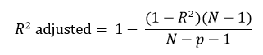

R2 = Sample R square

p = Number of predictors

N = total sample size

When we have a high dimensional data set, it would be highly inefficient to use all the variables since some of them might be imparting redundant information. We would need to select the right set of variables which give us an accurate model as well as are able to explain the dependent variable well.

We should also take care that the variables we’re selecting should not be correlated among themselves.

As we add more and more parameters to our model, its complexity increases, which results in increasing variance and decreasing bias, i.e., overfitting. So we need to find out one optimum point in our model where the decrease in bias is equal to increase in variance. In practice, there is no analytical way to find this point. So how to deal with high variance or high bias?

To overcome underfitting or high bias, we can basically add new parameters to our model so that the model complexity increases, and thus reducing high bias.

RIDGE REGRESSION

…

You can see that, as we increase the value of alpha, the magnitude of the coefficients decreases, where the values reaches to zero but not absolute zero.

But if you calculate R-square for each alpha, we will see that the value of R-square will be maximum at alpha=0.05. So we have to choose it wisely by iterating it through a range of values and using the one which gives us lowest error.

Now take a look back again at the cost function for ridge regression.

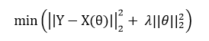

Here if you notice, we come across an extra term, which is known as the penalty term. λ given here, is actually denoted by alpha parameter in the ridge function.

Higher the values of alpha, bigger is the penalty and therefore the magnitude of coefficients are reduced.[[6]](#footnote-6)

PROCEDURE

Split the dataset into test and training set

Use the training set to train your algorithm

Use the test set to test the algorithm of a new and fresh bunch of data, we will compare them with the true value we have in the original dataset.

Training error :

NOTE: SHOULD we put the coefficients as well?

**linear regression** is a [linear](https://en.wikipedia.org/wiki/Linearity) approach to modelling the relationship between a scalar response (or [dependent variable](https://en.wikipedia.org/wiki/Dependent_variable" \t "_blank)) and one or more [explanatory variables](https://en.wikipedia.org/wiki/Explanatory_variable" \t "_blank) (or [independent variables](https://en.wikipedia.org/wiki/Independent_variable" \t "_blank)). The case of one explanatory variable is called [simple linear regression](https://en.wikipedia.org/wiki/Simple_linear_regression" \t "_blank). For more than one explanatory variable, the process is called **multiple linear regression**.[[1]](https://en.wikipedia.org/wiki/Linear_regression#cite_note-Freedman09-1) This term is distinct from [multivariate linear regression](https://en.wikipedia.org/wiki/Multivariate_linear_regression), where multiple correlated dependent variables are predicted, rather than a single scalar variable.

yi= w0 + w1(xi) + ei

where w0 is the intercept of the line and w1 is the slope;

ols

ei is the error and we assume E(ei)= 0 that is each predicted point is equally likely to be above or below the true value, so it is random noise. is the distance from our specific observation back down to the line

E[rt'] = O2I

 the relationships are modelled using [linear predictor functions](https://en.wikipedia.org/wiki/Linear_predictor_function) whose unknown model [parameters](https://en.wikipedia.org/wiki/Parameters" \t "_blank) are [estimated](https://en.wikipedia.org/wiki/Estimation_theory" \t "_blank) from the [data](https://en.wikipedia.org/wiki/Data).

the prediction is formed by the linear function computed in the given data point xi.

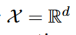The linear predictor for is a linear function

each parameterized by a vector w∈Rd of real coefficients. That is h(x) =w>x.

the feature is how does the median value price change if one feature is changing, having everything else constant

Use **matrix notation** for deriving the linear predictor

Each observation can be rewritten as an inner product between two vectors, w and h(x).

yi = ∑wjhj(xi) + ei

In case of multiple dimensions of the matrix features the line becomes a hyperplane

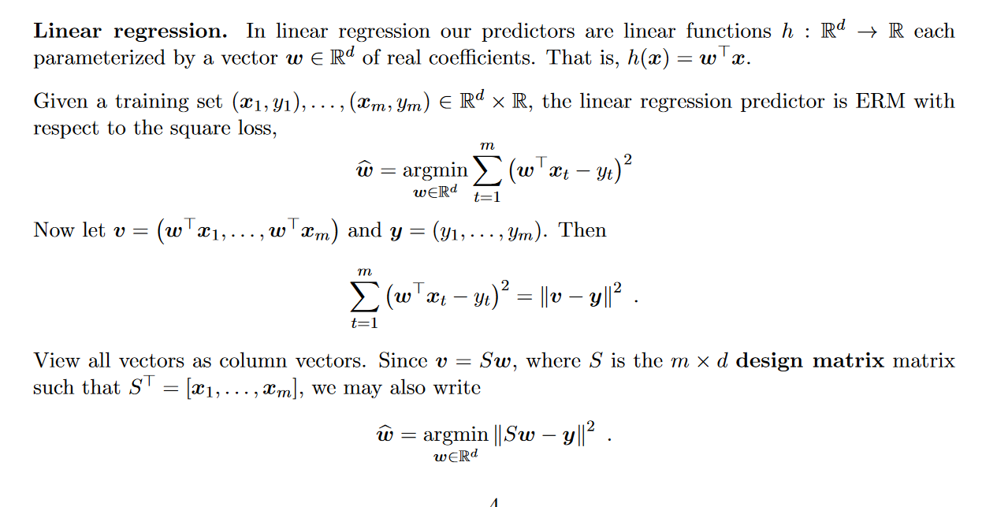



As the model complexity increases, the models tends to fit even smaller deviations in the training data set. Though this leads to overfitting, lets keep this issue aside for some time and come to our main objective, i.e. the impact on the magnitude of coefficients. This can be analysed by looking at the data frame created above.

It is clearly evident that the **size of coefficients increase exponentially with increase in model complexity**. I hope this gives some intuition into why putting a constraint on the magnitude of coefficients can be a good idea to reduce model complexity.

What does a large coefficient signify? It means that we’re putting a lot of emphasis on that feature, i.e. the particular feature is a good predictor for the outcome. When it becomes too large, the algorithm starts modelling intricate relations to estimate the output and ends up overfitting to the particular training data.

s ‘**L2 regularization**‘, i.e. it adds a factor of sum of squares of coefficients in the optimization objective. Thus, ridge regression optimizes the following:

#### Objective = RSS + α \* (sum of square of coefficients)

Here, α (alpha) is the parameter which balances the amount of emphasis given to minimizing RSS vs minimizing sum of square of coefficients. α can take various values:

<https://www.analyticsvidhya.com/blog/2016/01/ridge-lasso-regression-python-complete-tutorial/>

It is simply the weighted sum of each data point with coefficients as the weights. This prediction is achieved by finding the optimum value of weights based on certain criteria, which depends on the type of regression algorithm being used. Lets consider all 3 cases:

SIMPLE MODEL

1. initialize weights (say w=0)

2. iterate till not converged

2.1 iterate over all features (j=0,1...M)

2.1.1 determine the gradient

2.1.2 update the jth weight by subtracting learning rate times the gradient

w(t+1) = w(t) - learning rate \* gradient

This is formed from 2 parts:

1. 2\*{..} : This is formed because we’ve differentiated the square of the term in {..}
2. -wj : This is the differentiation of the part in {..} wrt wj. Since its a summation, all other would become 0 and only wj would remain.

Step #2.1.2 involves updating the weights using the gradient. This update step for simple linear regression looks like:

[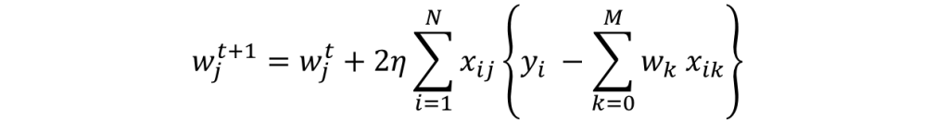](https://www.analyticsvidhya.com/wp-content/uploads/2016/01/eq4-1.png)

I hope you are able to follow along. Note the +ve sign in the RHS is formed after multiplication of 2 -ve signs. I would like to explain point #2 of the gradient descent algorithm mentioned above ‘**iterate till not converged**‘. Here convergence refers to attaining the optimum solution within pre-defined limit.

### 2. Ridge Regression

The objective function (also called the cost) to be minimized is the RSS plus the sum of square of the magnitude of weights. This can be depicted mathematically as:

[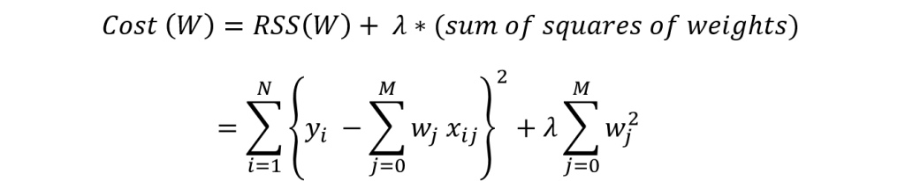](https://www.analyticsvidhya.com/wp-content/uploads/2016/01/eq5-1.png)

In this case, the gradient would be:

[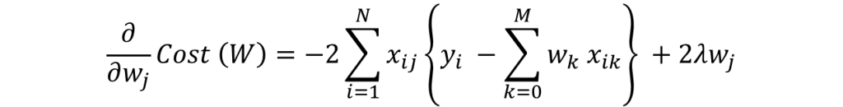](https://www.analyticsvidhya.com/wp-content/uploads/2016/01/eq6-1.png)

Again in the regularization part of gradient, only wj remains and all other would become zero. The corresponding update rule is:

[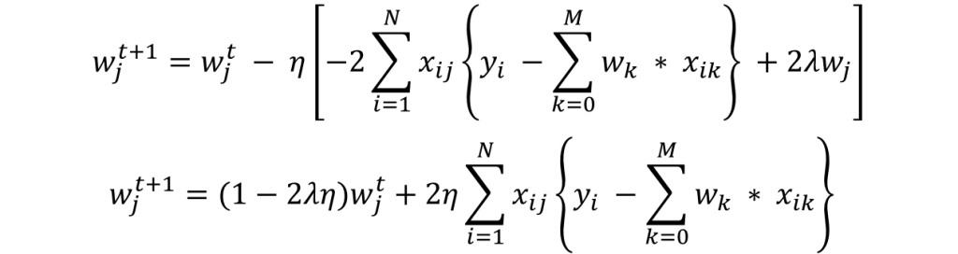](https://www.analyticsvidhya.com/wp-content/uploads/2016/01/eq7-1.png)

Here we can see that second part of the RHS is same as that of simple linear regression. Thus, ridge regression is equivalent to reducing the weight by a factor of (1-2λη) first and then applying the same update rule as simple linear regression. I hope this gives some intuition into why the coefficients get reduced to small numbers but never become zero.

Note that the criteria for convergence in this case remains similar to simple linear regression, i.e. checking the value of gradients. Lets discuss Lasso regression now.

1. initialize weights (say w=0)

2. iterate till not converged

2.1 iterate over all features (j=0,1...M)

2.1.1 update the jth weight with a value which minimizes the cost

The ridge coefficients are a reduced factor of the simple linear regression coefficients and thus never attain zero values but very small values

Handling the intercept in a way that it remains out of the regularization

**Ridge:** It is majorly used to prevent overfitting. Since it includes all the features, it is not very useful in case of exorbitantly high #features, say in millions, as it will pose computational challenges.

**Ridge:** It generally works well even in presence of highly correlated features as it will include all of them in the model but the coefficients will be distributed among them depending on the correlation.

enalizing the magnitude of coefficients should give us parsimonious models.

1. https://www.jsg.utexas.edu/helper/files/EstradaS2014.pdf [↑](#footnote-ref-1)
2. Dubin, Robin. (1998). Predicting House Prices Using Multiple Listings Data. The Journal of Real Estate Finance and Economics. 17. 35-59. 10.1023/A:1007751112669. [↑](#footnote-ref-2)
3. COURSERa [↑](#footnote-ref-3)
4. https://www.analyticsvidhya.com/blog/2017/06/a-comprehensive-guide-for-linear-ridge-and-lasso-regression/ [↑](#footnote-ref-4)
5. Video of coursera [↑](#footnote-ref-5)
6. https://www.analyticsvidhya.com/blog/2017/06/a-comprehensive-guide-for-linear-ridge-and-lasso-regression/ [↑](#footnote-ref-6)